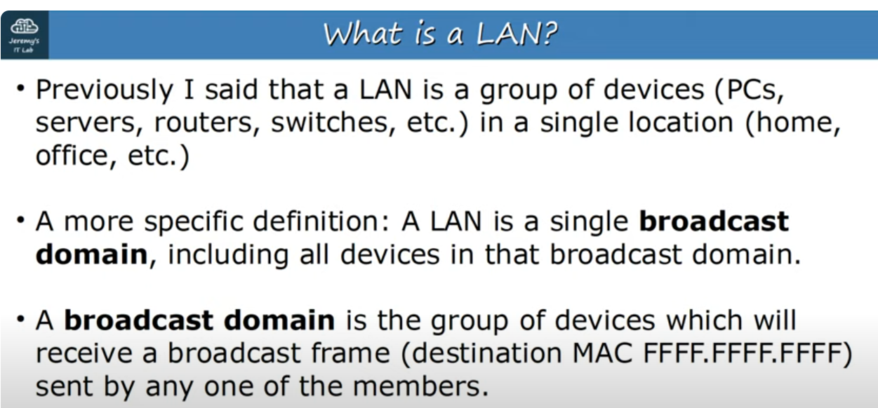
LAN and Broadcast domain
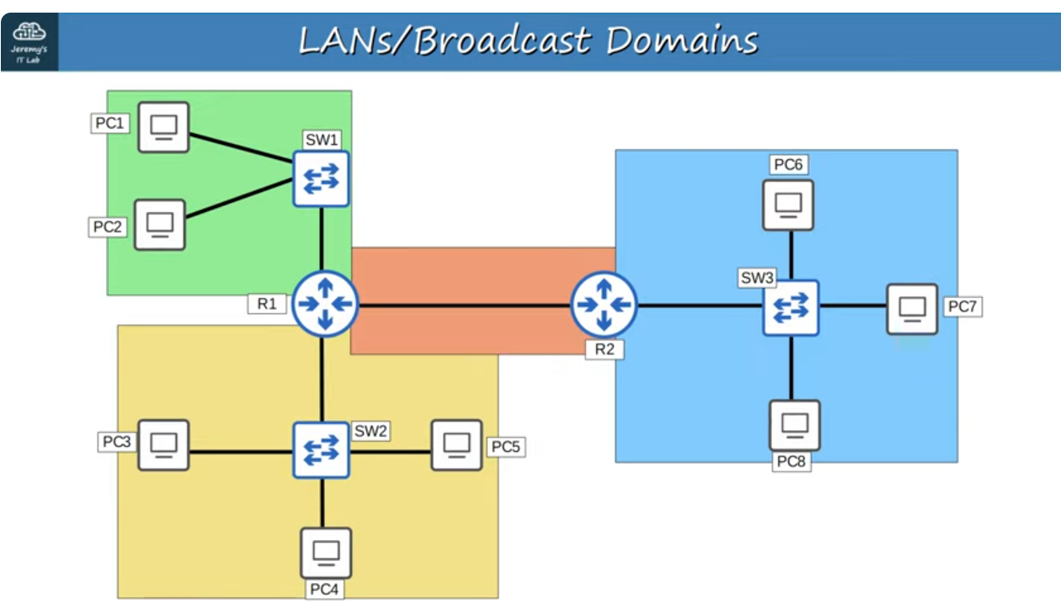
Broadcast domains,
Note: For example if PC1 sends a broadcast frame,it will be received by SW1,and SW1 will forward it to PC2 and R1.So R1 and PC2 will receive it,and R1 won’t forward it.So there So in green area all devices got that frame.That means green area is one broadcast domain. The same goes for other colored areas,they are broadcast areas,too.
Note: If R1 sends a broadcast frame out of it’s interface,which is connected to R2,it will be received only by R2.However,even though this is a connection with only two devices,it is technically a broadcast domain.
Note: In this network,there are 4 broadcast domains,therefore 4 LANS.
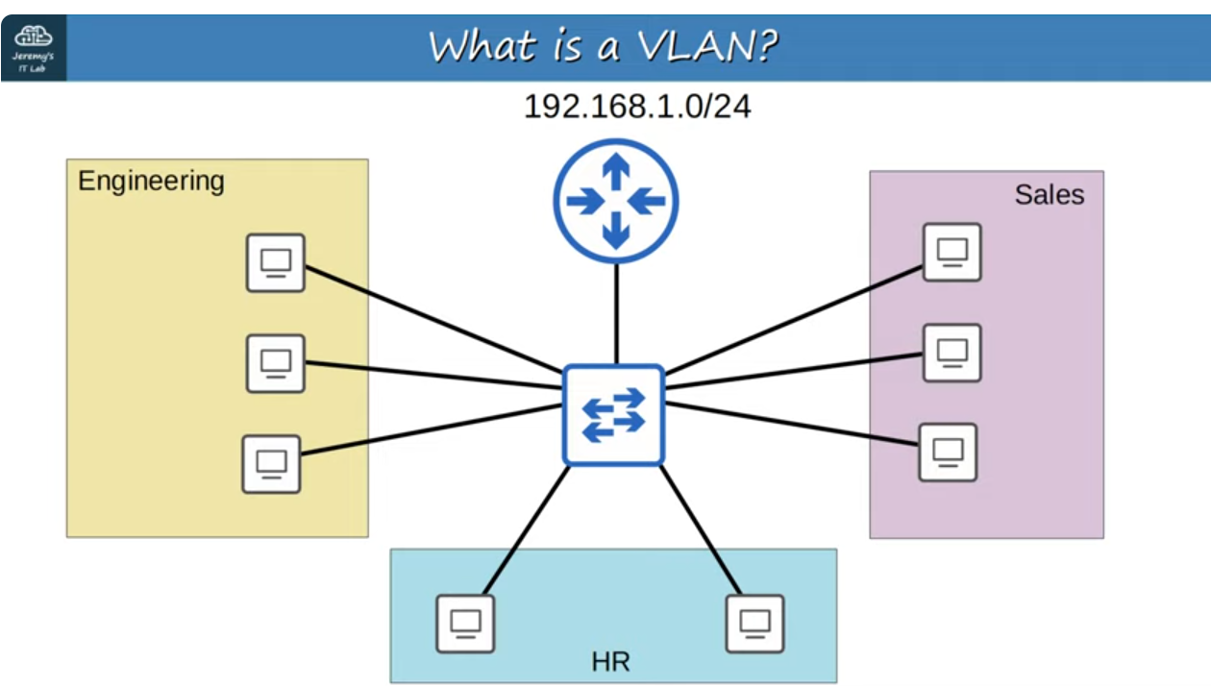
Small LAN of a company

